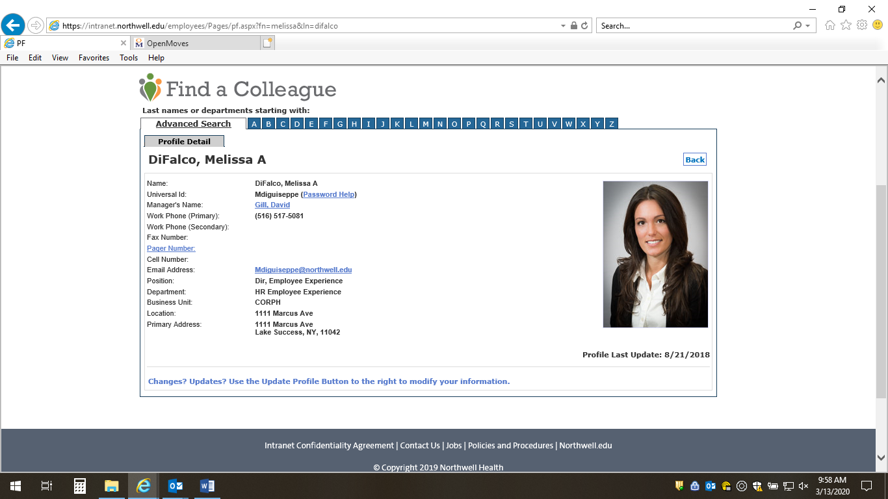**Melissa DiFalco**

Director, Employee Experience

Hometown: Commack, NY

Favorite genre of music: I listen to all types of music and am always up for a great song suggestion

Favorite TV show: If it’s on Netflix, I’ve probably seen it

Favorite Quote: “I get up every morning determined to both change the world and have one hell of a good time. Sometimes this makes planning my day difficult” – E.B. White

Melissa is responsible for the execution of system-wide employee experience initiatives helping to improve engagement across the full employee life cycle. Leveraging current programs to drive and support specific aspects of engagement, she is passionate about creating meaningful and memorable experiences for our team members.

Over the past 10 years, Melissa has gained experience in various divisions within Human Resources, focusing on specific areas that helped support Northwell’s engagement journey. A career highlight was facilitating the evolution and roll out of Northwell’s employee value proposition, Made for This.

Melissa has a master’s degree in business administration from Hofstra University and completed her undergraduate degree from SUNY Cortland (go red dragons!). Melissa is a mother of a beautiful 3 year old daughter Adriana and is married to her college sweetheart Dan.